Software Development Unit 33, 1.2

Anna Legaspi

# I can assess the suitability of development environments for given projects

There are a variety of different development environments. It’s important to know which is the most appropriate or suitable to ensure the success of the project.

In Unit 33, 1.1, I discussed the different environments that exists such as, the Development environment, Testing environment and Production environment. In this unit, I will explain the development environments I’ve used to create my website which will demonstrate its suitability.

## Website project

### Development environment: Visual Studio Community

The development stage is where developers code and create the project. Depending on the size and scale of the project, there are a variety of software environments available. I created my website using Visual Studio Community using a Windows 10 OS within my local drive. This environment was suitable in creating a simple four-page website (see table comparison of Visual Studio versions below). It would’ve been excessive to pay for the premium versions when the basic version was sufficient enough. In fact, I haven’t even utilised the basic versions full features.

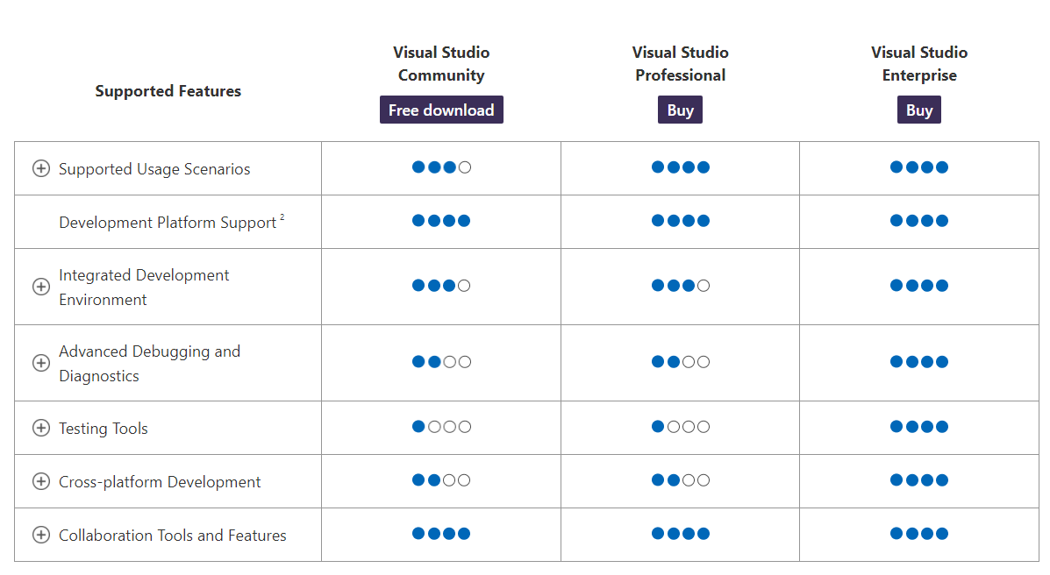

There are a lot of other available integrated development environments, software that developers use within the development environment. Their suitability is dependant on the type of project being created. There are text editors, Debugger, Code completion, Plugins and integrations, etc. Here are a few more examples:

* [Eclipse](https://www.eclipse.org/): popular for Java development. Compatible with Windows, macOS and Linux
* [Netbeans](https://netbeans.apache.org/): popular for Java. Compatible with Windows, macOS, Linux and Solaris

### Testing and Production environment: Google Chrome and Microsoft Edge

Visual Studio Community may not have a comprehensive testing tool like Visual Studio Professional/Enterprise, but it was easy enough to test the website manually. Since there was only four web pages to test, testing every single element within the website is easily completed manually. There is no need to have automation testing for the size of the project. To complete my testing, I simply created a script in Microsoft Excel and tested the website in two different browsers: Google Chrome and Microsoft Edge. This is also evidenced in my Unit 3, 3.1.

Although I was able to test my website manually, there are automation testing development environments available such as [Jenkins](https://www.jenkins.io/) which may be more appropriate for other projects.

## Agile/Scrum VS Waterfall

As much we are considering the type of software used to develop more software, it is also important to consider the type of environment the developers work in. I’m going into more detail about the differences between Agile and Waterfall which are two different ways of developing software.

|  |  |  |
| --- | --- | --- |
| **Attribute** | **Waterfall** | **Agile** |
| Goal | To create a completed product | Create a basic working software, with ongoing improvements and changes |
| Scope | Defined in Use Case at the start | Changes constantly depending on customer needs and requirements |
| Schedule | Is set based on the scope of the project. Considers extra time for any possible bugs and defects. | Updates every few weeks based on feedback received from customer until project is completed |
| Budget | Set and confirmed based on the scope. | Can change depending on the progress of the project. |
| Phases | Linear. There is no backtracking on completed phases. | There is flexibility to go backwards and forwards, depending on feedback received from customers |
| Working product | Will not be available until the testing phase. | Normally available in early phases, with feedback and further improvements made until complete |
| Measures of success | If scope has been covered as planned, within budget and on time. | Focused on user and customer satisfaction |

In addition to the chart above, ‘Agile’ is a set of values and principles that help software developers become efficient and better at their job. Scrum is the methodology in which Agile values and principles are conducted in a project.

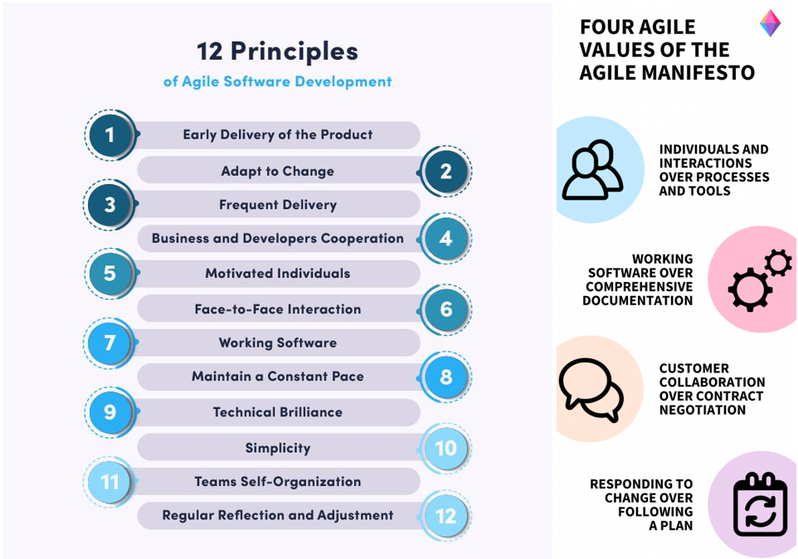

It is a popular belief that Agile is more beneficial than Waterfall in Software Development because of the following reasons:

* There is better customer satisfaction due to ongoing communication. If there are changes needed to be made to the software for the customer to remain competitive, Agile allows for these changes to be implemented in contrast to Waterfall.
* Costs less because of its flexibility and adaptability. Changes are constantly validated by the customer all throughout the project, instead of at the end.

Overall, the approach to the project must be decided on the beginning of the project and the pros and cons must be weighed and taken into consideration based on the project’s needs.